Revving Readers (Decoding Level 1)
This class is for students who are at the pre-reading level. This class is for students who would benefit from going over each letter in the alphabet and what sounds they make. This class is designed for students who need help with short vowel sounds. In this class, we will be working on blending consonant vowel consonant words (C-V-C words).
Lesson Title | Objective | Video Lesson
Lesson #1: | In this lesson we will:  - Introduce P and B.  - Identify pictures with P or B. | Click on the race car for your video!  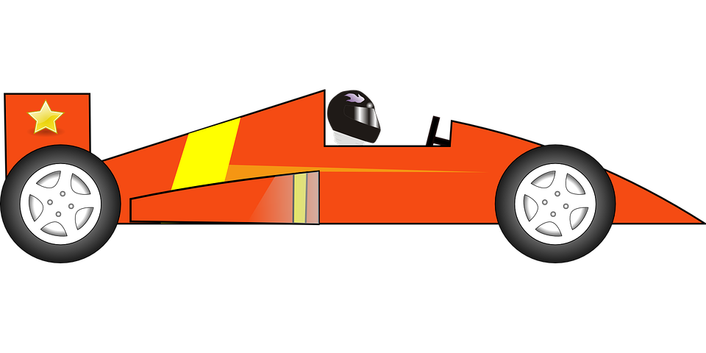  Links Mentioned in Video:  Revving Readers Website  Lively Letters p/b  Resources:  I can teach my Child to Read  Practice
Lesson #2: | In this lesson we will:  - Review P and B.  - Introduce T/D/A. | Click on the race car for your video!  Links Mentioned in Video:  Revving Readers Website  Lively Letters Review Video p/b  Resources:  I can teach my Child to Read  Lesson Notes:  Letter T book  Letter D book  Practice
Lesson #3: | In this lesson we will:  - Introduce F and V.  - Blend with short a. | Click on the race car for your video  Links Mentioned in Video:  Revving Readers Website  Lively Letters f/v  Page 19  Decodable Reader  Resources:  I can teach my Child to Read
Lesson #4: | In this lesson we will:  - Introduce M, N and O.  - Read a short a book with cvc words. | Click on the race car for your video!  Links Mentioned in Video:  Revving Readers Website  Lively Letters m/n/o  Decodable Reader  Resources:  I can teach my Child to Read
Lesson #5: | In this lesson we will:  - Introduce K and G.  - Review B and D.  - Read and blend both short a and short o, cvc words.  - Read a cvc book focusing on short o and a words. | Click on the race car for your video!  Links Mentioned in Video:  Revving Readers Website  Lively Letters k/g  Decodable Reader  Resources:  I can teach my Child to Read
Lesson #6: | In this lesson we will:  - Introduce L, R and U.  - Read and blend both short a and short o, cvc words.  - Read a decodable cvc book focusing on short o. | Click on the race car for your video!  Links Mentioned in Video:  Revving Readers Website  Lively Letters l/r/u  Decodable Reader  Resources:  I can teach my Child to Read
Lesson #7: | In this lesson we will:  Introduce S, Z and E.  Read a decodable cvc book focusing on short e. | Click on the race car for your video!  Links Mentioned in Video:  Revving Readers Website  Lively Letters s/z/e  Decodable Reader  Resources:  I can teach my Child to Read
Lesson #8: | In this lesson we will:  - Review of all p, b, t, d, f, v, m, n, g, k, l, r, s, z, a, o, u, e.  - Blend c-v-c words.  - Read a decodable c-v-c- book focusing on short a and e. | Click on the race car for your video!  Links Mentioned in Video:  Revving Readers Website  Decodable Reader  Resources:  I can teach my Child to Read

