Rad Readers (Beginning Decoding Level 3)
This class is for students who are reading beginning books but feel stuck in the beginning level. This class is for students who are able to read c-v-c words and c-v-c-e words(long vowel words with e at the end). In this class, we will focus on more complex special sounds such as special vowel combinations, variant vowels, consonants blends, r-controlled sounds, diphthongs, suffixes
Lesson Title | Objective | Lesson Title
Lesson #1: | In this lesson we will:  - Review long and short vowel sounds.  - Introduce and practice CVCe words.  - Decodable reader to practice CVCe words in context. | Click on the RAD logo for your video!  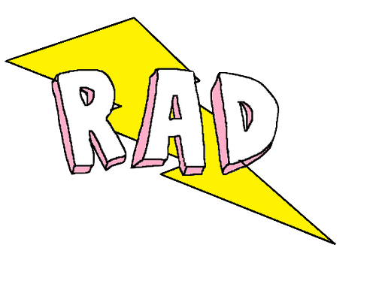  Links Mentioned in Video:  Rad Readers Website  “King Ed”  Decodable book  Resources:  I can teach my Child to Read
Lesson #2: | In this lesson we will:  - Review long and short vowel sounds.  - Review CVCe words.  - Introduce and practice long a words with ay/ai/a_e. | Click on the RAD logo for your video!  Links Mentioned in Video:  Rad Readers Website  Decodable book  Resources:  I can teach my Child to Read  Long A Word Cards
Lesson #3: | In this lesson we will:  - Introduce and practice four ways to make the short o sound: a/o/aw/augh.  - Blend and work with words.  - Read a decodable reader to practice words in context. | Click on the RAD logo for your video!  Links Mentioned in Video:  Rad Readers Website  Decodable book  Resources:  I can teach my Child to Read  Variant O Word Cards
Lesson #4: | In this lesson we will:  - Review all vowel sounds.  - Review CVCe words with more than one syllable.  - Review ai/ay/a_e words.  - Review short o: a/aw/o. | Click on the RAD logo for your video!  Links Mentioned in Video:  Rad Readers Website  Resources:  I can teach my Child to Read
Lesson #5: | In this lesson we will:  - Practice reading more decodable passages with the rules learned so far: CVCe, long a, short a, short o. | Click on the RAD logo for your video!  Links Mentioned in Video:  Rad Readers Website  Review-Fluency & Comprehension  Resources:  I can teach my Child to Read  The Power of Yet
Lesson #6: | In this lesson we will:  - Introduce three ways to make the long O sound.  - Practice blending words oe/oa/ow.  - Read long O decodable reader to practice words in context. | Click on the RAD logo for your video!  Links Mentioned in Video:  Rad Readers Website  Decodable book  Resources:  I can teach my Child to Read  Growth Mindset
Lesson #7: | In this lesson we will:  - Introduce r-controlled a: air/ear/are.  - Practice blending words.  - Read a decodable reader to practice air/ear/are words in context. | Click on the RAD logo for your video!  Links Mentioned in Video:  Rad Readers Website  Decodable book  Resources:  I can teach my Child to Read  Growth Mindset

