Marvelous Multiplication and Dazzling Division (Level 3)
We will learn how to Multiply and Divide
- Students should have mastered addition, subtraction, and have a basic knowledge of their times table/know how to use a times table chart.
- The focus of this class will be on multiplying and dividing larger numbers, decimals, and word problems. We will have fun integrating other skills and concepts (like Geometry) into multiplying and dividing.

Lesson Title | Objective | Video Lesson
Lesson #1:  What is multiplication?  How to multiply using 1 x 2 digit and 2 x 2 digit numbers. These skills are taught using both the traditional method and area models. Finding the area and volume of quadrilaterals is taught to reinforce multiplying and the meaning behind the area model. | I Can Statement:  I can add, subtract, multiply and divide rational numbers. 7.NS.A.3  I can understand and explain the value of digits in a larger number. 5.NBT.A.1  I can solve problems involving area, volume, and surface area of two and three dimensional figures. 7.G.B.6 | Click on the picture to access the Lesson #1 video:  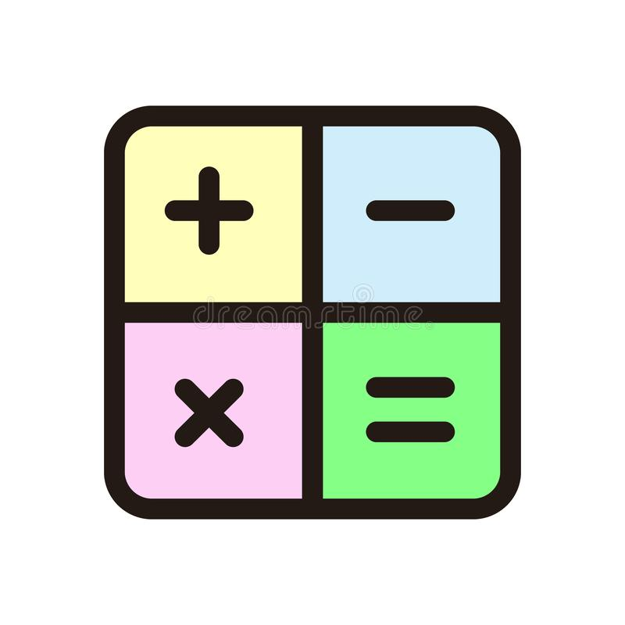  Videos and Extra Practice
Lesson #2:  In this lesson we will review and reinforce 1 x 2 and 2 x 2 multiplication using both area model and the traditional method. The pattern is taught so even larger numbers can be multiplied also. Word problems are introduced to reinforce the skills. | I Can Statement:  I can add, subtract, multiply and divide rational numbers. 7.NS.A.3  I can understand and explain the value of digits in a larger number. 5.NBT.A.1  I can use the products of rational numbers to describe real-world situations. 7.NS.A.2A | Click on the picture to access the Lesson #2 video:  Videos and Extra Practice
Lesson #3:  Multiply with decimals | I Can Statement:  I can add, subtract, multiply and divide rational numbers. 7.NS.A.3  I can read, write, and compare decimals to thousandths. 5.NBT.A.3  CCSS.MATH.CONTENT.5.NBT.A.2  I can explain patterns of decimal placement when a decimal is multiplied or divided by a power of 10.  CCSS.MATH.CONTENT.5.NBT.A.1  I can understand and explain the value of digits in a larger number.  CCSS.MATH.CONTENT.5.NBT.A.2  I can explain patterns of zeros in an answer when multiplying a number by powers of 10. | Click on the picture to access the Lesson #3 video:  Videos and Extra Practice
Lesson #4:  Use multiplication in circumference and area of circles | I Can Statement:  I can understand division by thinking about how one group can be divided into smaller groups.  I can fluently divide multi-digit numbers using the standard algorithm. 6.NS.2  I can find whole-number quotients and remainders with up to four-digit dividends and one-digit divisors. | Click on the picture to access the Lesson #4 video:  Videos and Practice
Lesson #5:  Introduction to to division with single digit divisor | I Can Statement: | Click on the picture to access the Lesson #5 video:  Videos and Extra Practice
Lesson #6:  Using single digit division find the average of numbers, area of a triangle, and area of a trapezoid | I Can Statement:  I can understand that fractions are really division problems. 5.NF.B.3  I can solve problems involving area, volume, and surface area of two and three dimensional figures. 7.G.B.6 | Click on the picture to access the Lesson #6 video:  Videos and Extra Practice
Lesson #7:  Introduction to division with a two digit divisor | I Can Statement:  I can use the quotient of rational numbers to describe real-world situations. 7.NS.A.2B  I can divide four-digit numbers (dividends) by two-digit numbers (divisors). 5.NBT.B.6 | Click on the picture to access the Lesson #7 video:  Videos and Extra Practice
Lesson #8:  Review and reinforce larger division problems with a two digit divisor | I Can Statement:  I can fluently divide multi-digit numbers using the standard algorithm. 6.NS.2  I can use the quotient of rational numbers to describe real-world situations. 7.NS.A.2B | Click on the picture to access the Lesson #8 video:  Videos and Extra Practice

