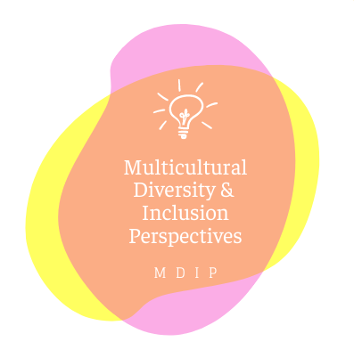

The MDIP (Multicultural Diversity and Inclusion Perspectives) team is committed to highlighting diversity amongst people and cultures in our nation, lifting the voices of those who may not have historically been recognized or valued, and providing diverse perspectives on both historical and current events. We desire to help students develop their critical thinking skills by teaching them how to think and not what to think while providing the tools to help them celebrate the diversity of culture and thought within our country. Within this framework, our objective is to create opportunities for conversation and understanding as well as supply tools to help staff and families take actionable steps towards positive change.