

Today’s Career Tech Education (CTE) is a program of study integrating core academic knowledge with technical and occupational knowledge. Upon completion of a CTE pathway, students have the knowledge base required to sit for and pass the exam leading to industry certification, giving them the opportunity to apply for a career-ready job. While CTE is career-focused education preparing students for the world of work, completion of a pathway prepares students for college as well and is a valuable addition to one’s application, giving students a boost when applying to a particular program of study.

Watch this CTE presentation video to learn more about CTE and how it could benefit your student.

Please share this family-friendly resource with students who are interested in CTE.

If your student is taking a CTE course through an online vendor or a local program, please make sure to fill out the Course Adoption Survey. Since CTE courses need to be reported in a very specific way, please help the High School team keep track of student enrollments by filling out the survey.

CTE is a program of study integrating core academic knowledge with technical and occupational knowledge. There are CTE Pathways available in the Industry Sectors listed below. To find out about the possible careers and CTE pathways click on the industry sector below.

Industry Sectors:

  Agriculture & Natural Resources |   Arts, Media, & Entertainment | 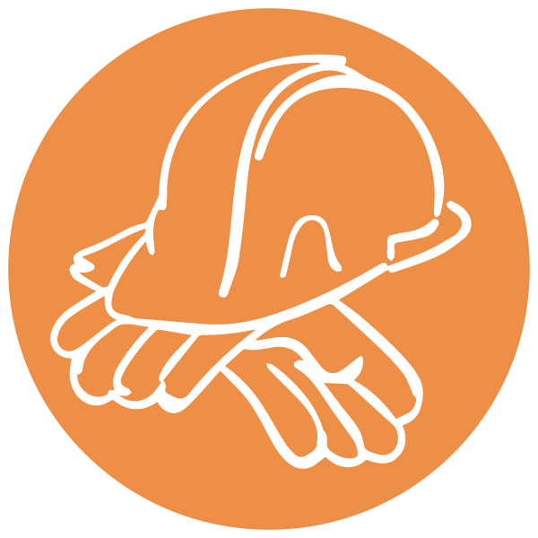  Building & Construction Trades |   Business & Finance |   Education, Child Development, & Family Services
  Energy, Environment, & Utilities |   Engineering & Architecture |   Fashion & Interior Design |   Health Science & Medical Technology |   Hospitality, Tourism, & Recreation
  Information & Communication Technologies |   Manufacturing & Product Development |   Marketing, Sales, & Services |   Public Services |   Transportation Sector

