## **4 Year College Entrance Requirements**

Students who plan to apply to a 4-year college right after high school graduation should plan to meet “a-g” requirements. These requirements are mandatory for students who apply to the CSU or UC systems, and recommended for students who plan to apply to private and out-of-state colleges and universities. The minimum “a-g” requirements are summarized below:

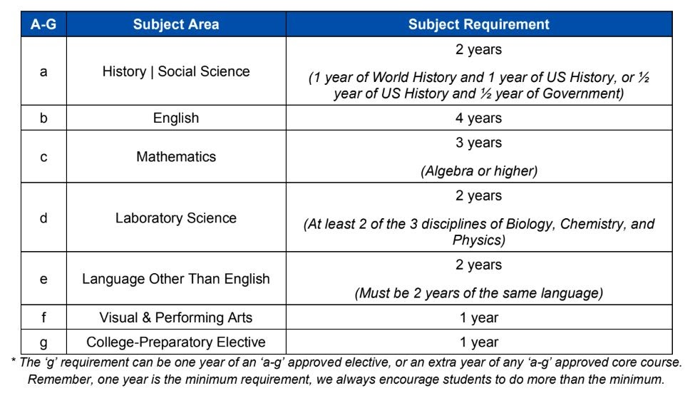

Students who plan to apply to the UC or CSU systems will need to take courses that are “a-g" approved. “A-G” approved science classes must include labs and all “a-g” courses must be completed with a grade of C or better. There are alternative ways to meet “a-g” requirements through testing and community college courses. Students can check the progress of their “a-g” requirements by consulting with their high school counselor. Subject requirements will vary for private and out-of-state colleges and universities. However, most students who are eligible for UC admission and fulfill the “a-g” requirements will probably meet the admission requirements for most of the private and out-of-state colleges and universities. Students should also plan to take the SAT or ACT. SAT Subject Tests are usually optional; however, students who are applying to specific departments or highly selective schools will want to check with the admissions office of the college or university of interest to verify requirements.