# **Special Academic Instruction (SAI)**

## **What is SAI?**

SAI stands for Specialized Academic Instruction and it is one way that we meet the free and appropriate public education (FAPE) requirement that we are mandated to offer. The class can be 1:1 or small group instruction based and are taught by qualified special education teachers.

[SAI FAQ](https://docs.google.com/document/d/1KVrWBkqxNjRVPQFkXha32Y-Z47A_qC2-5Pi-cXub_Ks/edit?usp=sharing) [FAQ for K-8 Mod/Severe SAI](https://docs.google.com/document/d/1pmnHWwpFwc-8nPNQfOaRz9eSY68fBWaRdwUU9OB_2K4/edit?usp=sharing) [What is a Reading Specialist?](https://docs.google.com/document/d/1KVrWBkqxNjRVPQFkXha32Y-Z47A_qC2-5Pi-cXub_Ks/edit?usp=sharing)

## **SAI Google Classroom Support Documents**

These resources are being shared with the learning coaches of students in SAI classes by their SPED teachers. They are here so you can see them too.

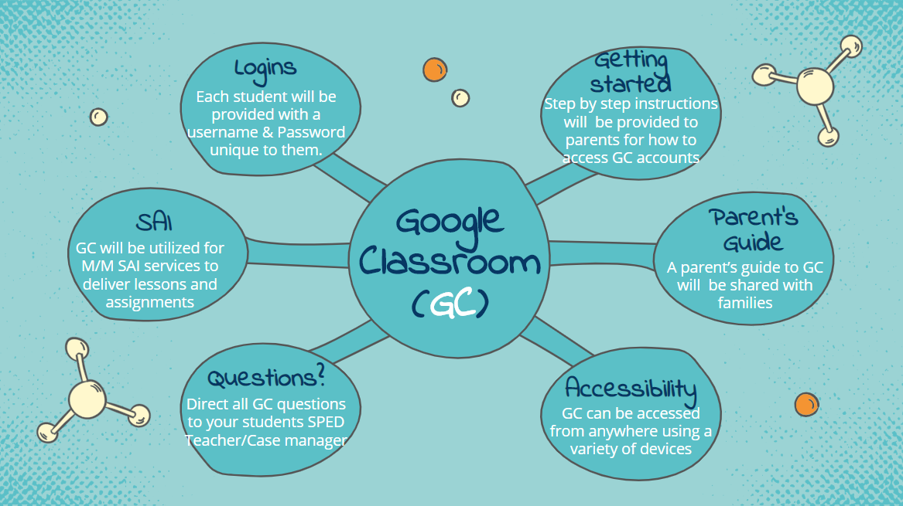

[Parent's Guide to Google Classroom](https://docs.google.com/document/d/1UwF3qyqyBmVROc4sXbfAn_Xuzm-J-dwbt5uD3MM509I/edit?usp=sharing) [GC Parent's Guide](https://docs.google.com/presentation/d/18L-94O2HbdjQM5TbsvNoun3Rd0UzfU-IkjFUtj0KKxo/present#slide=id.p1) [GC Student's Guide](https://docs.google.com/presentation/d/1grcU903oNXfekCrUZLK-huGgp_wq80iZd7RJikNEatM/present#slide=id.g8a79d40f89_0_79)