# **NCAA**

We are excited to support our student athletes by offering NCAA approved high school courses. It is important that teachers and families understand the process for NCAA eligibility so we can be sure to set students up for success.

As soon as you know that a high school student on your roster is a student athlete interested in NCAA eligibility, please complete this survey: [NCAA Student Survey](https://form.jotform.com/lindaq/ncaa-student-survey).

Also, please be sure to say “yes” in the NCAA area on the IGP. There is an IGP specific to NCAA students, located [here](https://docs.google.com/document/d/1CUevrPsfBCiSxBn03rseZc6wBdEaqd4DI1GFGj_AIx0/edit?usp=sharing). If you are creating a new IGP, please make a copy of the NCAA IGP and share it with your HSSC or High School Counselor once you've completed the document.

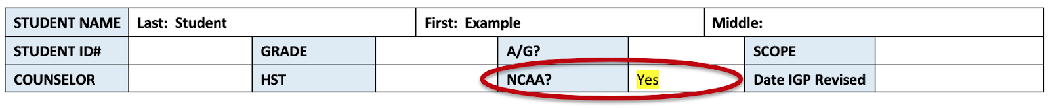

It’s very important you notify the high school team of any students hoping to meet NCAA requirements immediately. In order to meet NCAA eligibility requirements students must:

* Review the [NCAA’s guide for the college bound student athlete](http://fs.ncaa.org/Docs/eligibility_center/Student_Resources/CBSA.pdf) with the family. This includes information regarding course sequence, GPA, SAT and ACT requirements. It also includes the steps to create an account with the NCAA eligibility center. You can also review the [NCAA's initial-eligibility brochure](http://fs.ncaa.org/Docs/eligibility_center/Student_Resources/IE_Brochure.pdf?j=83784146&sfmc_sub=1297856592&l=7822357_HTML&u=730777611&mid=10892399&jb=112) with the family; this is a quick reference guide.
* Develop a graduation plan that will meet the NCAA’s core course requirements.
* Take unmodified **Edgenuity** or **High School Virtual Academy** courses for all core courses, or other NCAA approved curriculum.

**Some other approved curriculum options are:**

* Apex Learning
* ASU Prep Digital
* edOptions Academy (Edmentum)
* FLVS
* iLead
* Mr. D Math
* Silicon Valley
* UC Scout
* Williamsburg Academy

* Please note that most of these providers offer versions of their courses that are approved and versions that are not approved. Contact your HSSC to make sure you order the correct version.

**HQT-Led Edgenuity NCAA Courses**

If your student plans to take HQT-Led Edgenuity courses, please note that there is a slight delay in updating Edgenuity courses from when they are first ordered in the COS. Please have your student check that the NCAA courses are loaded before they start working in the course.

The NCAA HQT-Led Edgenuity courses will have course names that look like the following:

