# **HS Directory**

# **High School Directory**

Please click [here](https://docs.google.com/document/d/1sGxA4xcHiILyd8R0hh0QMg_ckzIFWgemnAvC2PGanWY/edit?usp=sharing) to see the appropriate point of contact for high school questions.

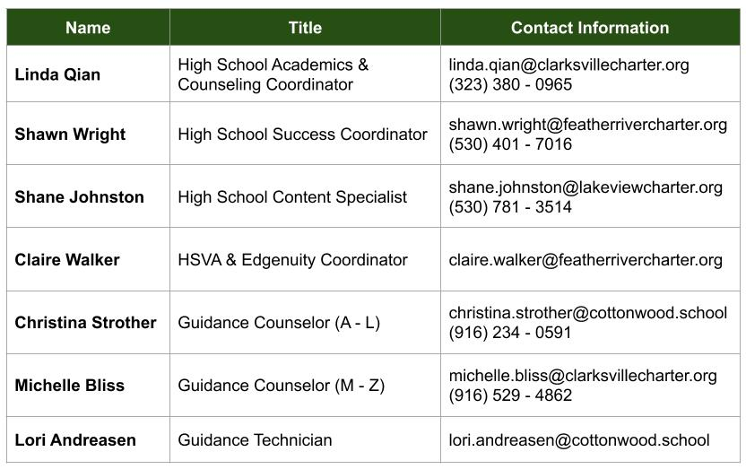

For a directory of High School Virtual Academy and Edgenuity HQTs, please click [here](https://docs.google.com/document/d/1f5m7ZwGMINYuoyqLoyTWueHP1-sqU2iIMNbAeyXwGCc/edit).