# **Foster & Homeless Youth**

### **Basic Information:**

* [Education Code 51225.1](http://leginfo.legislature.ca.gov/faces/codes_displaySection.xhtml?lawCode=EDC&sectionNum=51225.1) allows foster youth, homeless/transitional, probation students, and migratory students to be exempt from Inspire graduation requirements that exceed state requirements if:
  + The student transfers schools after completing 2 years of high school
  + The student is not reasonably able to complete Inspire graduation requirements within 4 years of high school
  + The educational rights holder or student (if over 18 years old) must determine whether it is in the youth’s best interest to graduate under AB 167/216
* The student must meet [California graduation requirements](https://www.cde.ca.gov/ci/gs/hs/hsgrtable.asp).
* The Guidance Counselor will evaluate the student’s records and determine whether the student is reasonably able to complete high school graduation requirements.

### **Graduation Requirement Comparison:**

### 

### **HST Role:**

* If your student is eligible for the AB 167/216 graduation path, then the student will be enrolled in the appropriate graduation path in School Pathways.  
    
  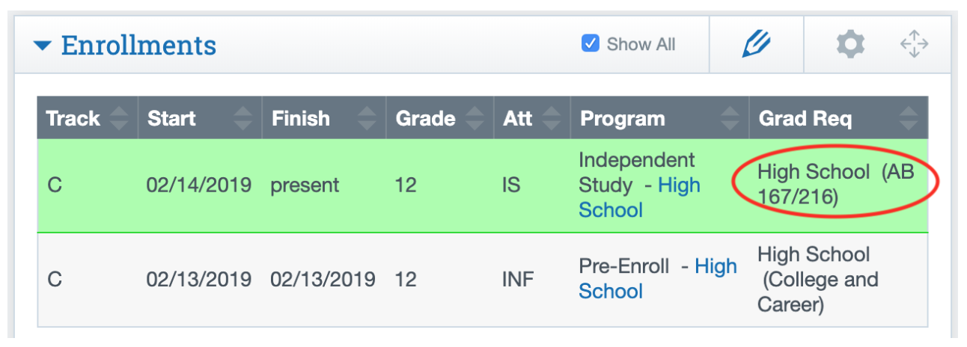
* If your student is eligible for the AB 167/216 graduation path, please make sure that they have access to curriculum, tech, and enrichment as soon as possible. It is vital that students start working towards graduation goals immediately.
* Documentation of the student’s eligibility will be uploaded to the student’s Dashboard under the Notes section in Pathways.
* If you believe your student should be enrolled in the AB 167/216 graduation path and there is no documentation in School Pathways, please reach out to your Guidance Counselor immediately.
* If your student is ineligible for the AB 167/216 graduation path, their status can be re-evaluated at any time during the school year. Please continue to monitor your student’s course progress and notify the inspire counselor immediately if you think the student may be struggling.
* Please note, students who graduate with the AB 167/216 may or may not be able to apply to a 4-year college right after high school graduation. Please consult with the Guidance Counselor to see what the student’s post-high school options are.