# **Algebra Requirement**

## **Algebra Graduation Requirement**

Per the [CDE](https://www.cde.ca.gov/ci/gs/hs/hsgrmath.asp#:~:text=Minimum%20graduation%20requirements%20for%20mathematics.&text=Complete%20at%20least%20two%20courses,Algebra%20I%20or%20Mathematics%20I.), students must complete at least 2 years of mathematics in grades 9 to 12. Students must also complete a course that meets the content standards of Algebra I or Integrated Mathematics I prior to graduating high school, this requirement can be met during middle school or high school. If your student took a high school level Algebra I or Integrated Mathematics I course in middle school, they must still complete 2 years of mathematics in grades 9 to 12.

To check whether your student has met the Algebra Graduation Requirement, please visit your student's Dashboard in School Pathways and review the Transcript.

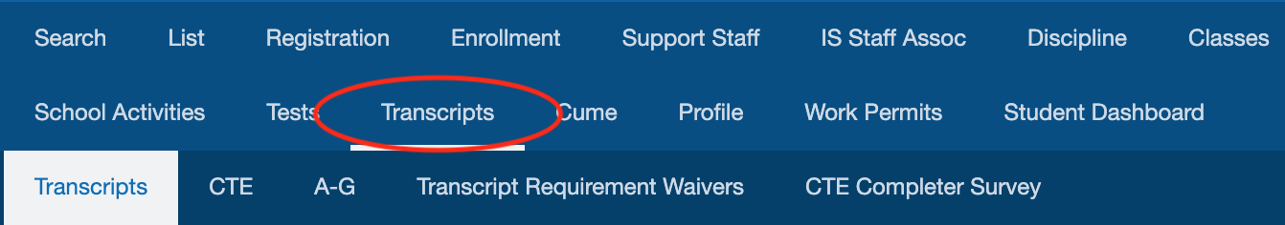

On the left-side menu, look for the "Algebra Requirement" section to see if your student has met the requirement. Please notify your High School Guidance Counselor if you believe the "Algebra Requirement" needs to be corrected.



For more information on the Algebra Requirement, watch the short tutorial video below: