# **A-G Requirements**

## **What are the A-G Requirements?**

Students who plan to apply to a 4-year college right after high school graduation should plan to meet “a-g” requirements. These requirements are mandatory for students who apply to the CSU or UC systems, and recommended for students who plan to apply to private and out-of-state colleges and universities. For more information, please visit the [UC Subject Requirement page](https://admission.universityofcalifornia.edu/admission-requirements/freshman-requirements/subject-requirement-a-g.html).

The minimum “a-g” requirements are summarized below:

To meet minimum admission requirements, students must complete 15 yearlong high school courses with a letter grade of C or better — at least 11 of them prior to their last year of high school.

Keep in mind that taking approved high school A-G courses isn't the only way to satisfy these requirements. Students may also meet them by completing college courses or earning certain scores on SAT, Advanced Placement or International Baccalaureate exams. Students should work with their high school guidance counselor if they have any questions about A-G requirements or the college admissions process.

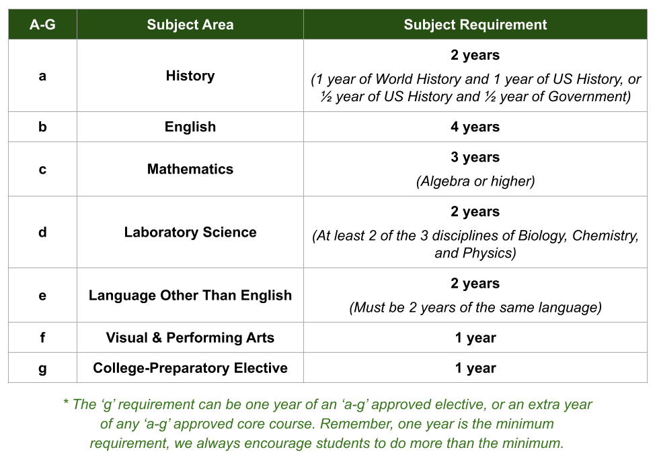

## **Which courses are A-G approved?**

To check and see if a course is A-G approved, please refer to the [UC A-G Course Lists](https://hs-articulation.ucop.edu/agcourselist). Each school has its own A-G Course List, to see your school's list please refer to the links below:

* [Clarksville Charter School](https://hs-articulation.ucop.edu/agcourselist/institution/5114)
* [Cottonwood School](https://hs-articulation.ucop.edu/agcourselist/institution/5485)
* [Feather River Charter School](https://hs-articulation.ucop.edu/agcourselist/institution/5090)
* [Lake View Charter School](https://hs-articulation.ucop.edu/agcourselist/institution/5502)

If your student would like to take an A-G approved course that is not listed on the school's [UC A-G Course Lists](https://hs-articulation.ucop.edu/agcourselist) and/or in School Pathways, please read the instructions below and fill out the [Course Adoption Survey](https://form.jotform.com/lindaq/course-adoption-survey).

## **A-G, Honors, & AP Course Adoption**

[Course Adoption Survey](https://form.jotform.com/lindaq/course-adoption-survey)

**Does my course need to be adopted or self-certified?**

**Step 1:** Check the [A-G Online Publisher Directory](https://hs-articulation.ucop.edu/agcourselist/publisher-directory) for your curriculum provider*. Are they listed?

* No - please use an [A-G course outline](https://north.sites.beehived.com/high-school/courses/course-outlines) if available. Most of the course outlines are A-G approved unless otherwise indicated. If no outline is available for the course, please work with your HSSC to determine options.
* Yes - please continue to Step 2.

*\* Please note, not all curriculum providers on this list can be used by our students. Some of the online publishers provide nonsecular curriculum, which our students cannot use.*

**Step 2:** Verify the course has added to your school's A-G Course List. Each school has a separate A-G Course List, please use the links below to view a specific school's A-G Course List.

|  |  |  |  |
| --- | --- | --- | --- |
| [Clarksville Charter School](https://hs-articulation.ucop.edu/agcourselist/institution/5114)  [A-G Course List](https://hs-articulation.ucop.edu/agcourselist/institution/5114) | [The Cottonwood School](https://hs-articulation.ucop.edu/agcourselist/institution/5485)  [A-G Course List](https://hs-articulation.ucop.edu/agcourselist/institution/5485) | [Feather River Charter School](https://hs-articulation.ucop.edu/agcourselist/institution/5090)  [A-G Course List](https://hs-articulation.ucop.edu/agcourselist/institution/5090) | [Lake View Charter School](https://hs-articulation.ucop.edu/agcourselist/institution/5502)  [A-G Course List](https://hs-articulation.ucop.edu/agcourselist/institution/5502) |

* If the course is listed, your student is set to order and begin the course.
* If the course is not listed, please complete the [Course Adoption Survey](https://form.jotform.com/lindaq/course-adoption-survey).

*\* For AP courses, the survey must be completed by December 30 each year. Also, please review the* [*AP section*](https://app.beehively.com/high-school/courses/ap-courses) *of the handbook and share the* [*College Board website*](https://apstudents.collegeboard.org/register-for-ap-exams) *with your families so they are aware of testing options.*

### **School Pathways A-G Courses:**

To check whether the course you have added in School Pathways is A-G approved, pay close attention to the course code.

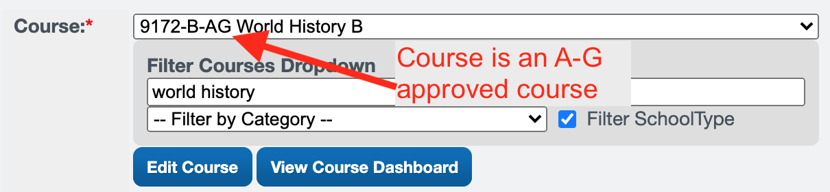

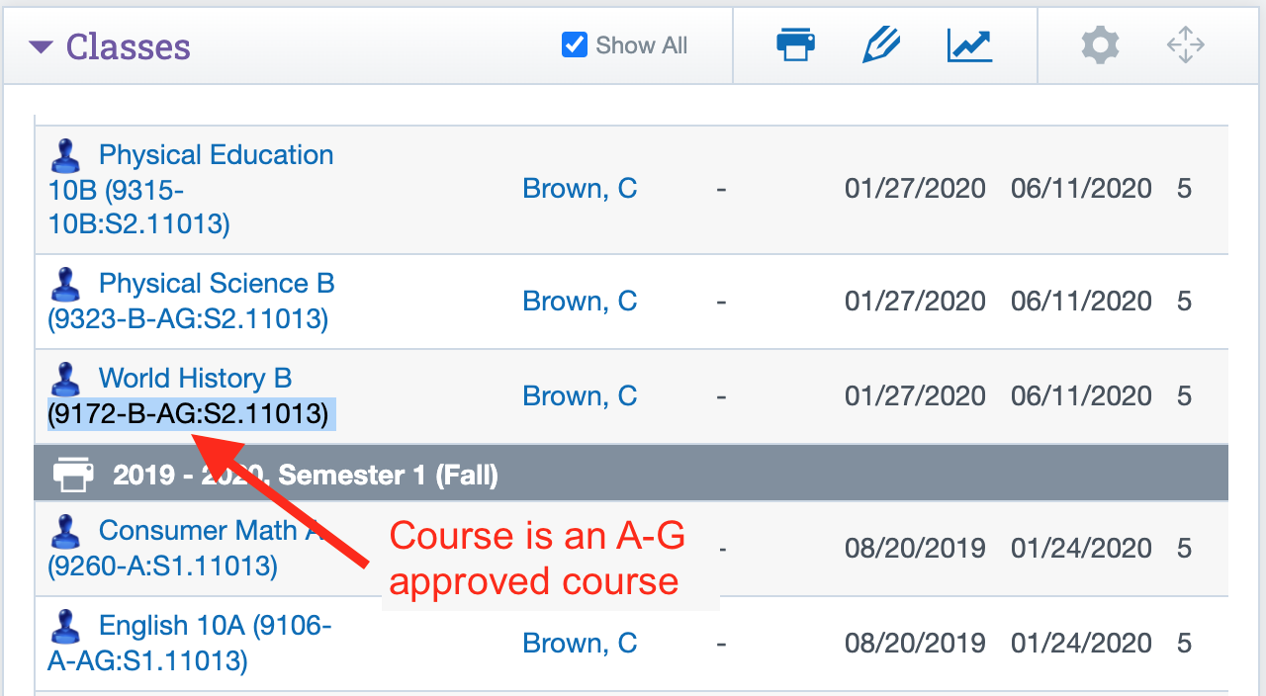

## **FAQs**

**1. What if my student doesn't want to attend a 4-year university?**

It's a good idea to keep all options open, especially if the student is unsure of their post-high school plans. Since our course outlines are already A-G approved, many of our students meet the majority of the A-G requirements by the end of 11th grade. Students can always decide what they want to do as they get closer to graduation, but we should encourage students to keep all possibilities open.

**2. What if my student did not take any A-G courses before enrolling with our school, but they still want to meet A-G requirements?**

Out-of-state, homeschool, and private school students may have taken coursework that was not A-G approved. There are different ways a student can meet A-G requirements. Students with mixed records should work with their high school guidance counselor to make sure they will meet all A-G requirements.

**3. What should my student do to have a competitive college application?**

Unfortunately, the college admissions process has become more competitive over the last few years. Students should plan to go beyond the bare minimum admissions requirements. Students should think about their post-high school plans and study topics that interest them. Students should plan to take a rigorous course of study that includes honors, AP, and/or college courses. Please work with your high school guidance counselor to ensure that your student takes the appropriate high school courses.

**4. What if my student would like to use a vendor for their A-G course?**

Check the [A-G Online Publisher Directory](https://hs-articulation.ucop.edu/agcourselist/publisher-directory) for your curriculum provider. If the vendor is not listed, they do not have a readily adoptable A-G course. The student will need to follow an A-G Course Outline. Please ask the vendor for a syllabus and please work with the family to supplement lessons accordingly. If you would like ideas for vendors, please review the [Vendors Offering HS Courses](https://docs.google.com/spreadsheets/d/1vQcWxaREz-zgzh3XPeBKksBrmAYUop6etjlAyqkmYSQ/edit?usp=sharing) list.