# **Work Samples**

Students are required to work in all assigned subject areas throughout each learning period. This work shows evidence of school attendance as well as the progress they are making toward mastery of the I CAN Statements. Please bring a BODY OF WORK from each learning period to your monthly HST meeting so that you may collaborate with your teacher on student progress. Your teacher may request a sample from a particular subject to be uploaded into our system. Please note that samples must be original work done by the student and completed during the current learning period. Also, all work samples must be secular (non-religious) in nature.

## **TK-8**

* 1 work sample will be collected each learning period.

## **High School**

* 1 work sample from each subjected on your Master Agreement will be collected each learning period.

## **Formatting**

These things MUST be include at the TOP of each sample:

* Student's first and last name and the date (including the month and year).
* If the sample is handwritten, student's name and date should also be handwritten (by the student if at all possible)
* If the sample is typed, it is ok for the student's name and date to be typed as well
* Subject of the sample
* Grade given by parent

📸 *Photo work samples must use a* [*Photo Work Sample Template*](https://docs.google.com/document/d/1jLkicxlqOcaLd-k_WCw5-mQZx8ptIE64fJkBs4wP4eA/edit)

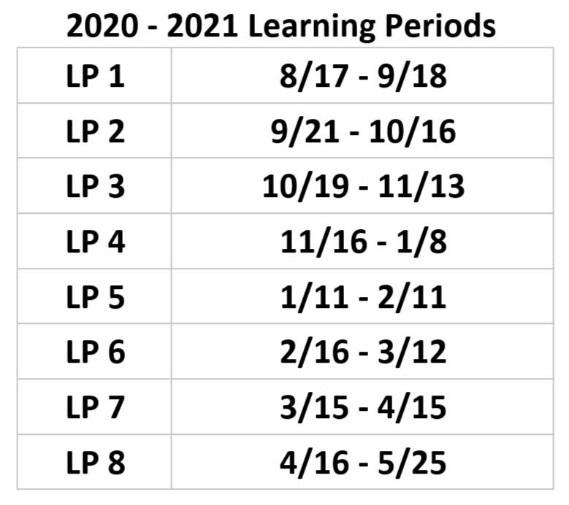

## **Photo Work Sample Template**