# **Test Scores**

[How to Pull Testing Scores (PDF)](https://drive.google.com/file/d/1KvP8AAvQrPk3-QXLHZsugBZ0zCyCzK_3/view)

1. Go to the student dashboard and look under test scores
2. Click on the graph symbol “View CAASPP/ELPAC PDF’s”  
     
   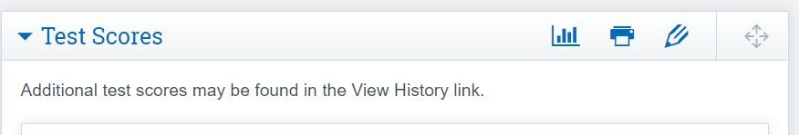
3. This will pull up the PDF’s for CAASPP scores:  
     
   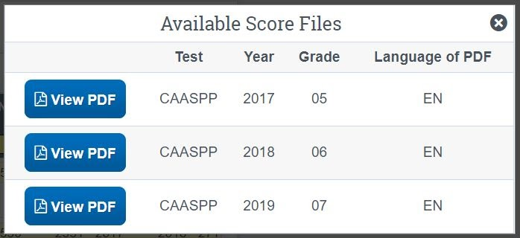

*Note: If you are unable to see your students test scores it could be because they switched scopes this year and their test scores are still located in the previous scope until they are moved over (which should happen soon). Most of our Cottonwood students are in this boat.

If this is the case, you will need to go into oversight and search the student’s name up at the top. And then click on their name under the old scope.