### Tips for How to Start Homeschooling!

Are you starting to homeschool or need fresh inspiration? Here are tips on how to start homeschooling, homeschool teaching strategies, units you could cover and more!

This whole situation is tough… for so many reasons. I’ll try to offer some practical starting points below, but first let me say that you can do this!

For one thing, you know your kids better than anyone else.

Homeschooling does not have to look like traditional schooling:

You are free to make your homeschool environment, hours and days look the way you want! Whether you work or not, it can be done. This can be TOUGH, but your kids are resilient and they WILL learn. In fact, with your help, they’ll thrive!

Because you are homeschooling with the help of a State funded Charter School, you have a lot of flexibility. You can use a traditional curriculum, covering most subjects or, you can follow the kids’ interests. You can follow what your public school is doing or you can create your own curriculum path. You can create unit studies or you can have your kids take online classes. You can join co-ops or work things out with other families (maybe… if you feel comfortable, that is!) to tackle different subjects.

You actually can do a lot more hands-on activities in the homeschool setting… everything from using math manipulatives to doing science experiments, playing games, using sorting cards, and learning outdoors! You can really liven things up… in a way that is challenging in a classroom full of 25-30 kids!

There are Seasons in Homeschooling:

* When you train for a big race, there are intense days when you sprint and go full-on, there are distance days when you go long, slow runs, AND there are rest days. Without those rest days, you would never reach your full potential. Those are the days that your body repairs itself and builds muscles. It’s on those rest days when you become stronger. The same goes for education.
* You need time to re-energize. You need time to plan & prepare. You need sick days and mental break days. Those are OKAY!
* There will be times when your homeschool is in the groove and science experiments are getting done and checklists are being accomplished. But there are other times when things slow down, when you are all delving deep into things and other subjects slip by the wayside. And finally, there will be days when “nothing” appears to get done.
* All of this is natural! We have support available for you!

Remember Your “Why”:

* Every family has a unique list of reasons why they started homeschooling… and why they continue to homeschool. What is *your* WHY? Write down all the reasons you homeschool (or make a mental list). Find inspiring quotes that speak to you about education in general. Then, when you are having a hard day, pull out that list and read it over. It will help bring your motivation back up and will help you keep going on the hard days.

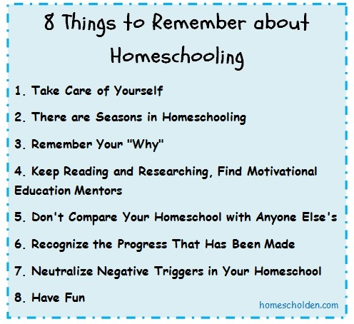

When you are starting out:

For any age student, the following ideas can be adapted to fit into the I Can Statements.

1. Read, Read, Read. I love to see children draw pictures, create dioramas, posters, videos, or anything that gives them a way to retell their favorite parts of the story. This is a great way to learn summary writing for the older kiddos!
2. Create: children are great teachers. Ask them to create something, and teach you or a sibling how to do it. This can be art, building, cooking, or any kind of problem solving! When they teach, they store the information in a different part of their brain, which means it will be there for longer than if someone just tells them how to do something!
3. Observe and Record: Have your children choose something to observe for a week or longer. They can keep track of their findings in a notebook and give the family a presentation on what they learned at the end of the week, or longer if the project will take longer. For example, My son observed the behavior of our cats in the evening. They always want canned food at 5pm. When he started to feed them at 4 instead, he observed that they began asking for the food earlier and earlier...they knew it was coming at 4! We also observed a rose, from bud to opening, to losing its petals. Another fun thing is to find the flowers that close in the evening, and open back up in the sunshine! Research why this happens and what types of flowers behave this way
4. PE: Jump rope, swimming, skating, any type of physical activity can be recorded. Goals can be set and reached. It is fun to see how many push ups or sit ups they can do and try to add 2-4 more each day. At the end of the recording period, has there been improvement?
5. Cooking: Homeschooling is a great time to learn some basic cooking skills! Talk about reading directions, measuring, kitchen safety, and presentation skills. Take pictures!
6. Make a book: This is one of my favorite things to have kids do. They show off their creativity and they are great keepsakes! You can look up different [book binding methods here](https://babbledabbledo.com/design-for-kids-recycled-handmade-journals/), or just staple some pieces of paper together! You can also buy some blank hardcover [books here](https://www.barebooks.com/) and let your kids create like crazy!
7. Play games to build math and language skills. There are several games that kids can play and they don’t even realize how much they are learning! Some of our favorites are Boggle, Scattergories, Yahtzee, Scrabble, Bananagrams, and there are so many more. For young children, simple dice games are easy to create. Who can roll the highest doubles, or the highest number combinations, for example. Games teach so many skills and give us an opportunity to gently teach our children while having fun!
8. Nature Walks: identify trees, plants, birds and other wildlife. Talk about the terrain, the weather, the sky, and the rivers, lakes or mountains you see. Draw pictures, do internet studies on birds, flowers, lakes, anything! Let them get to know their area and community!
9. Puzzles: these are wonderful for building thinking skills!
10. Letter writing: let your students write letters to family and friends. They can tell them about their new school and other events in their lives. This is a great way to encourage writing in the long lost form of writing letters!